Renju lesson on May 2, 2002

Hello everyone! Welcome to Online Renju Class. We will change the opening today, just as agreed last time. Do you remember the name of today's opening? Indeed, i9 is the one to be studied. Japanese have given the openings some cute names, moons and stars, but I never remember them.. :) The evaluation of the opening: If you have to make the evaluation in the scale of 0 to 100, where 0 is white win and 100 is black win, then what number would you choose for this opening? Most of you set the evaluation somewhere around 85-95. Very good. I agree with you. Considering the amount of research that has been done in i9 opening, 90 might be the good evaluation. The opening may be even 100 points, but we have not proved it yet. Likely, a good player takes 100% as black in i9 each time. But, when the opponent is someone like Nakamura, then the white's 10% might have some effect in result. However, it is easy to see that if the black player wants to force the draw in i9 opening, one can do it easily, without big complications. Even against world top players. In 1993, I remember playing i9 opening with both colors in WC. I remember using crazy 4th move 4-h6 against Kozhin and I won as white. In the game where I was black, the opponent played 4-h9. I won after long struggle. Which means, I did not get a clean win from the opening. Ok, we can as well begin with this 4-h6 today, and play the first steps of my game from 1993.
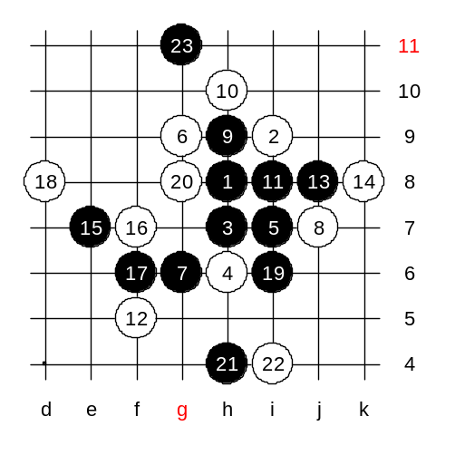
Kozhin was confused by my opening choice at that time, and he was not prepared for that. He offered two 5th moves, both out of theory. He offered 5-i7 and 5-h10. It does not necessarily mean those moves are bad. The moves out of theory are just the ones people didnt study before. They might be bad, they might be good. White offers a very strong resistance by the 6th move. White continues with active style, avoiding the structures of positional game. I planned during the game that if he plays 9-f9 then I reply with 10-j9! Anyway, he chose careful 9-h9 at that time. Moves 12 and 14 - the best ones I think. Moves 12 and 14 surround the blacks. Moves until 18 were logical and expected. With move 19, black is trying to escape from being surrounded. Move 21 - a pseudo-attack that works well because it can control the upper white pair from the point g7 (a potential black VCF threat). Perhaps I could have played a little better here as white, but I did not have that aggressive playing style at that time. I assumed white advantage in upper side is so big and all I needed to do was to block passively below and wait the end of black's actions. Black chose to defend with 23rd move because it became too hard to keep attacking so that white's upper pair would remain under black's control. The following moves do not matter here. It is enough to see what is the outcome of failed 5th move.

So, which 5th moves are the correct ones? Yes, the 5-g8 and 5-i8 bring black sure win. Very difficult win, I should say.

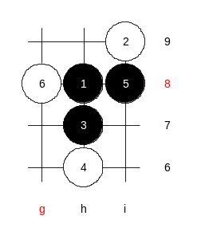
Let us first learn the 5-i8. Since one of the main 6th moves 6-g8 leads to i6 opening which we have studied before, we can skip lots of work here. :) How many of you can recognize the variant of i6 opening if white plays 6-g8? Yes, good, you all remember 7-j7. And besides that, we mentioned black having another winning 7th move. Where is it? Yes, 7-g6 wins, too. Those who forgot the win can to our website and pick the i6 lesson for 4 cp. :)
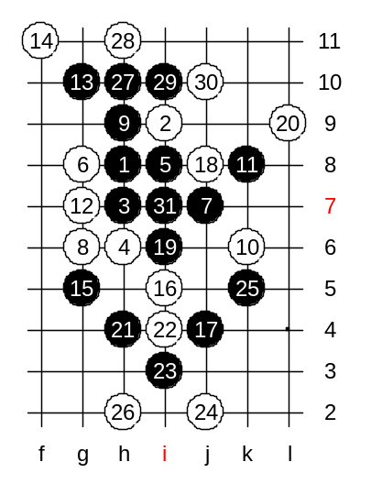

Let us quickly review the main variant, ok?
The 31st move is the end of a beautiful black attack. This is the hardest win I guess.

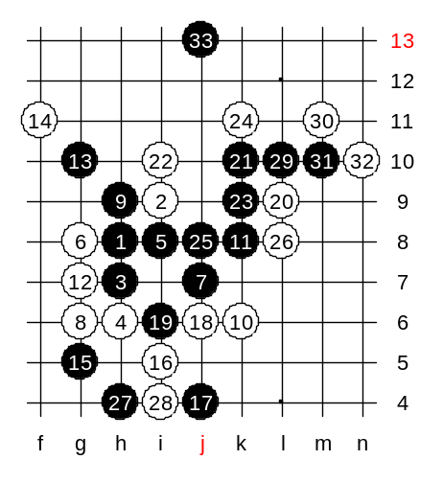

Another 18th move loses too. Still remember it?
There it is.

Any questions? Next week we will study deeper about this 5th move. I now announce the lesson to be over, here are the credit points for participation.

